Appendix 2 (November 2020)

To assist the parish with preparation of a business case the following information has been supplied in advance of any formal discussion with the Suffolk Highway engineers.
Assumptions have been made at this stage that there are no utility services (gas, water, electricity, telephone) in the grass verge proposed for the cycle track, any services found may require diversions or work around at considerable additional cost. No estimate has been made for land purchase, legal costs or provision of street lighting.
A preliminary ball park cost estimates is required to permit Parish to create a business case for the cycle track.
The top priority route selected is on the B1106 adjacent Fornham Park, cycle track proposed on west verge of B1106, n.b. eastern side has a drainage ditch.
Map of area, route under review shown in pink
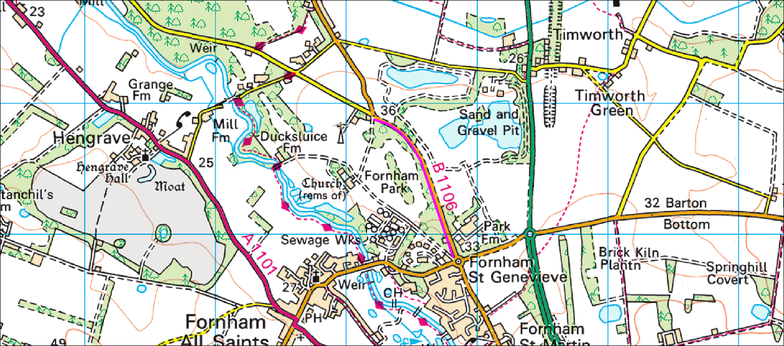

Google photos of B1106 heading north
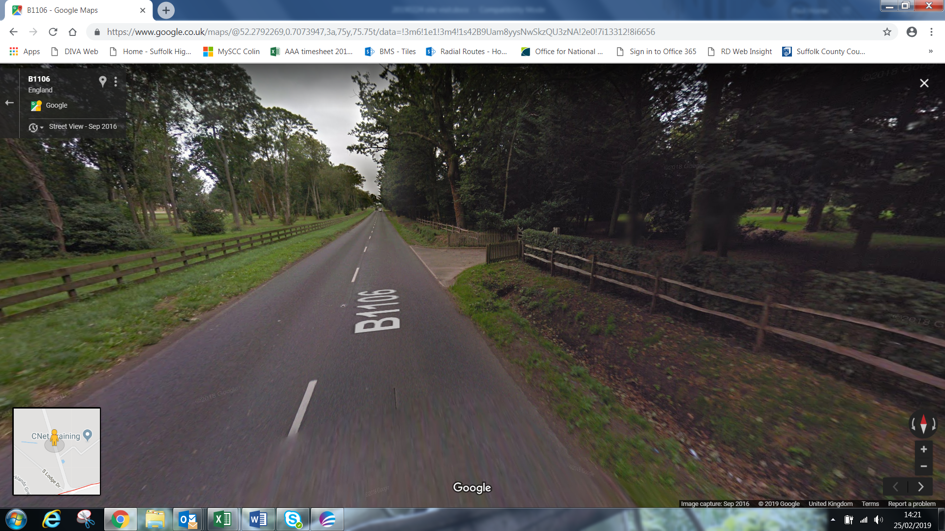

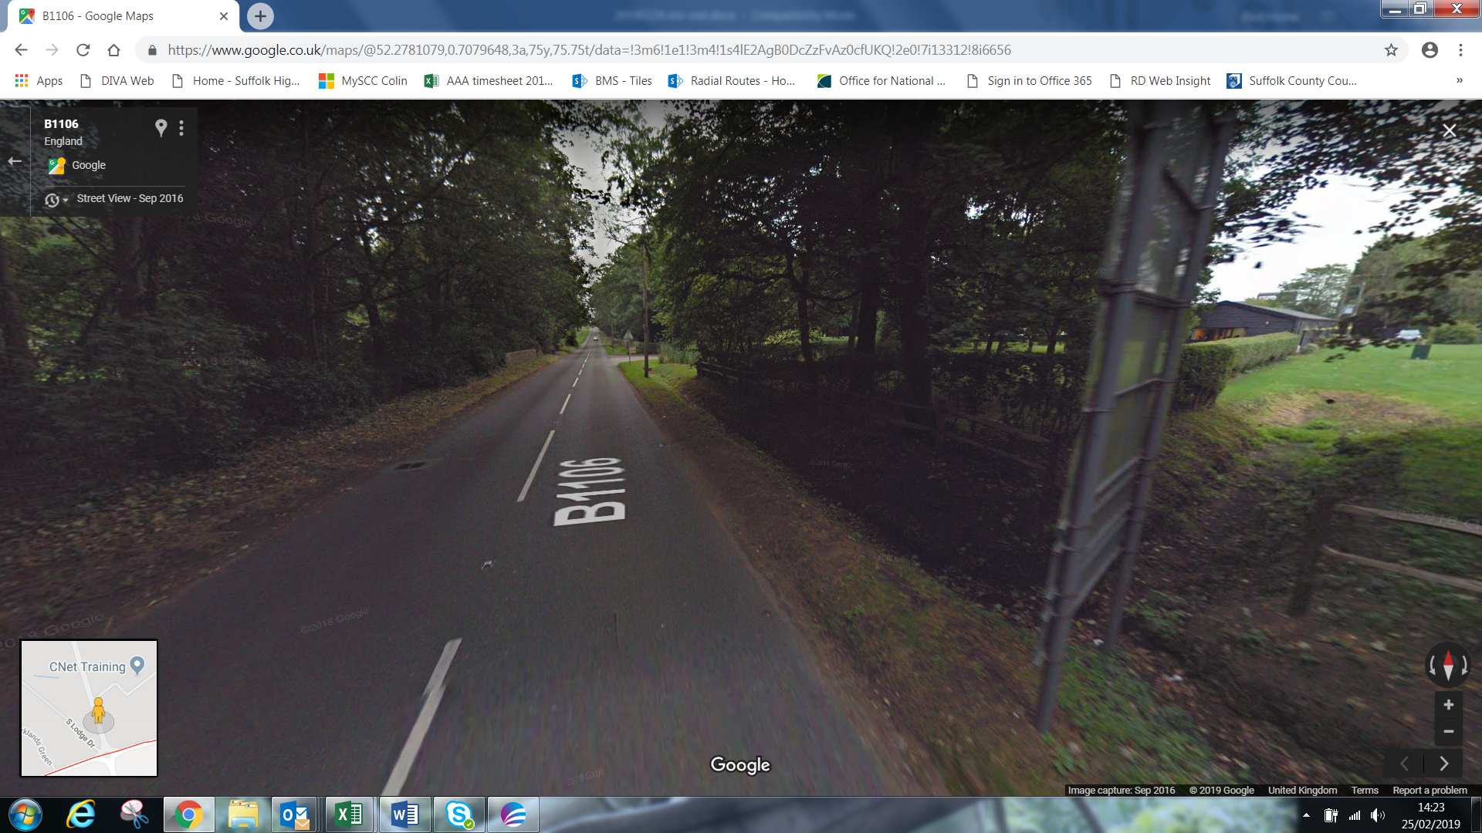
Approx distance of route 1.3km from B1106 Fornham St Genevieve roundabout to the fork in road to West Stow/Culford, proposed cycle/ped path on west side.
Indicative mapping of the public maintainable highway boundary includes grass verge of varying widths along the distance, over 3m at the north end, but narrowing to only 0.5m on the bend, the majority of the route is under 3m. This presents a significant challenge with a 2 way cycle track guidelines of 3m width, with a minimum of 2.5m.
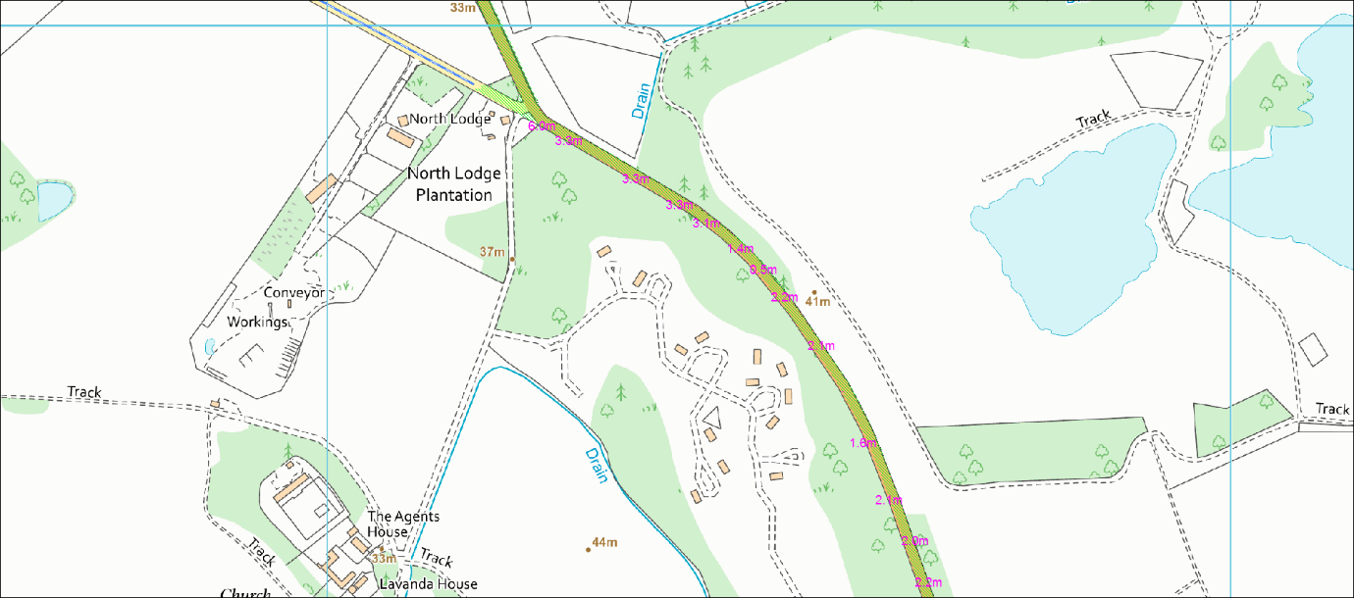
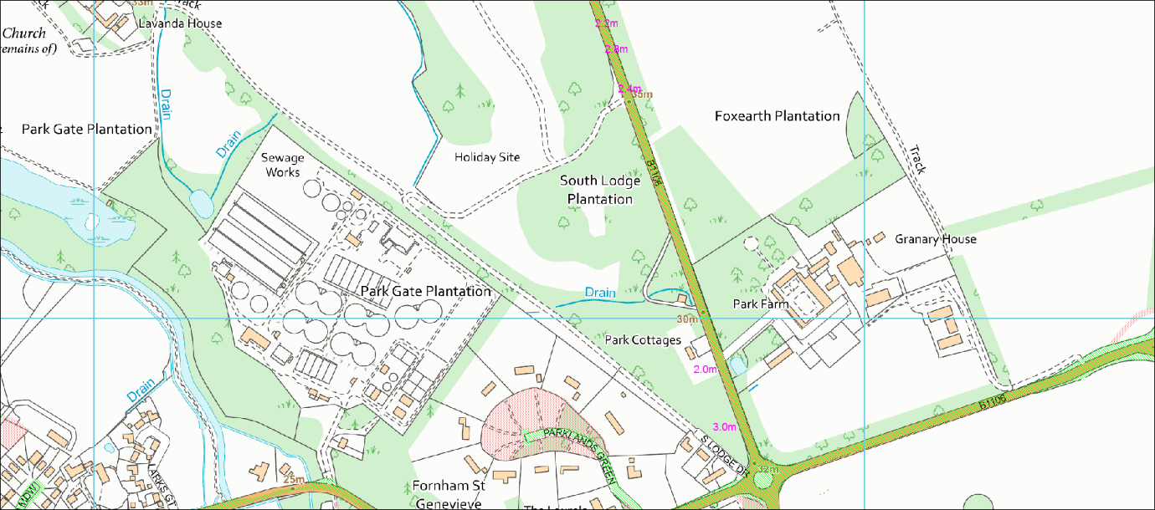

High level estimate of costs to provide a cycle / pedestrian path for 1.3km on the route is between £450,00 - £700,000, these costs are indicative only and have NOT been confirmed by Suffolk Highways who will be responsible for providing a formal feasibility study and a quote. Estimated costs for the feasibility study, which would include outline drawings and cost estimates for the work £5,000 - £10,000.
Subsequently at detailed design we will need to obtain utility company estimates and make contact with land owners etc, only then we will really know if £450,000 - £700,000 is a realistic figure.

